READ-ME FILE

on

**“MAC address using LAN network”**

**BY**

Ashish Shah



* Introduction

This project is about to find MAC addresses of the devices that are connected to the LAN network using Python (version 3.5). At the initial stage, we have to connect the computer to the LAN network. Then by entering the IPv4 address of that LAN network, we can display MAC and IP addresses of connected networks.

* Code:



First of all, we import the system. Then in order to get Date and time in output, datetime property is imported. At last, scapy library is imported.

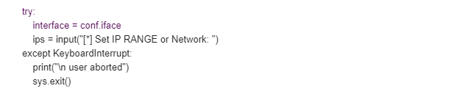

Then we created a variable called interface to save the value of input. Conf.iface is used to configure the IP address which is given as an input.

KeyboardInterrupt is used to let the user know that keyboard interruption occur while compiling the code. After which the massage “user aborted” displays.

D:\Computer networks\capture 3.PNG

This portion of code runs when no interruption occur and “Scanning” will be displayed while it runs.

Datetime.now() is used to display date and time when code starts and it is saved in the variable called “starttime”.

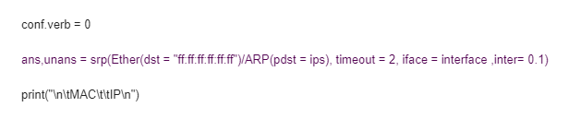

“Conf.verb” is a variable that is used to set the verbosity of scapy library to zero. So that when we run a program, We don’t get multiple output.

Srp variable is used to send the packet and get back the answer.

Ans.unans variable stores the answers of srp variable.

Pdst function is used to identify the MAC and IP addresses.

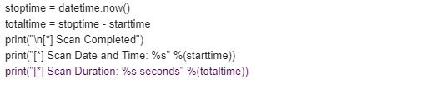

Total time used to count the time between start and stop.

Then, we print the completion statement, Total time and scan duration.

* Conclusion

Python language always requires various libraries to execute the code. At the beginning we tried couple of libraries like Nmap, scapy etc.